Battle of Neighborhoods:

**Business Problem:**

Toronto is one of the largest cities and the financial hub in Canada and it is often compared with New York. Toronto is highly populated and open to new business always which interested my client in starting new physical training center. People are always about their health and fitness and in recent time, more people use physical training center. Even though there are more training centers than historical days, still the most of them are crowded. In this project we will explore the neighborhoods of Toronto, perform analysis and recommend a best neighborhood to start a new physical training center.

Data:

**Geographical Data:**

Using python goopy library to get the coordinated of the location.

"http://cocl.us/Geospatial_data"

**Toronto Data:**

Data Source: I will use the “<https://en.wikipedia.org/wiki/List_of_postal_codes_of_Canada:_M>” to identify the neighborhoods of Toronto for further analysis in this project.

**Existing gym data:**

Data Source: Foursquare API, which will provide us with all the existing venues of each neighborhood.

**Analysis Methodology:**

Scrape the data from the Wikipedia page.

Create a data frame with the scraped data defining the neighborhoods.

Using geopy library get the coordinates of each neighborhood

From foursquare API get the venues details of each neighborhood including category.

Slice the Physical/Training center data into a data frame

**Business Questions:**

Which Borough has maximum number of neighborhood ?

What are the different types of venues available in the neighborhood ?

Which neighborhood has the highest number of Physical/ Training center ?

**Analysis**:

Import all the required python libraries.

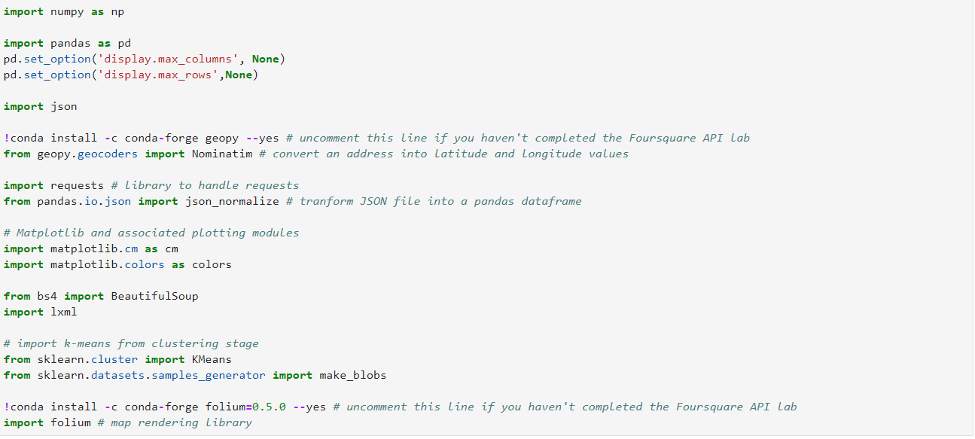

**Scraping the data from wikipedia**



**Creating a data frame and updating each row.**

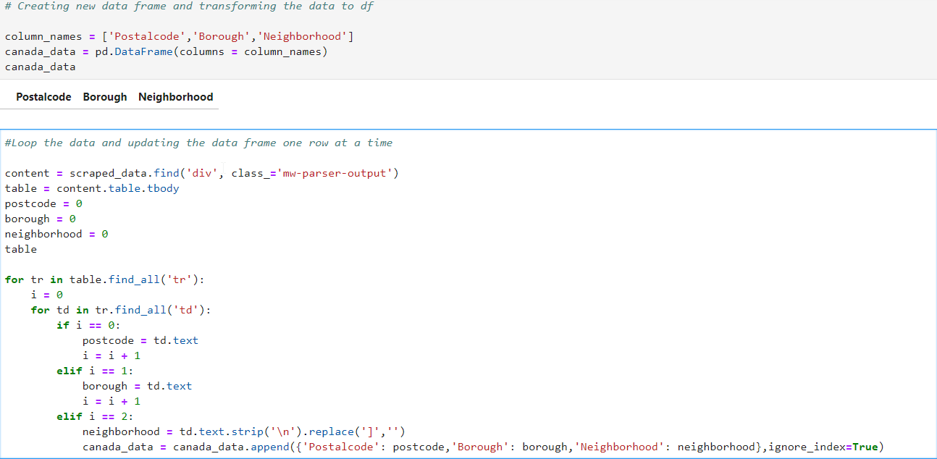

**Data Cleaning:**

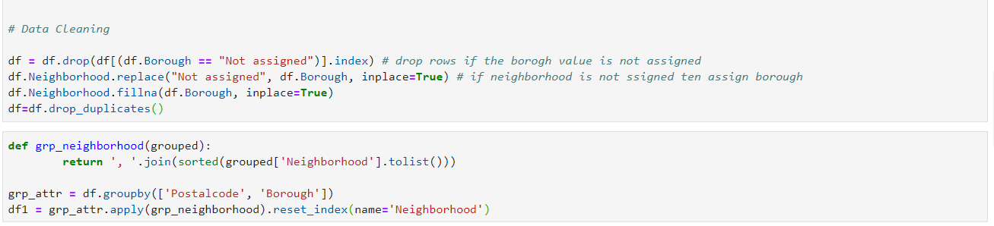

**Loading the geospatial data for each neighborhood**





**Visualizing the Boroughs**

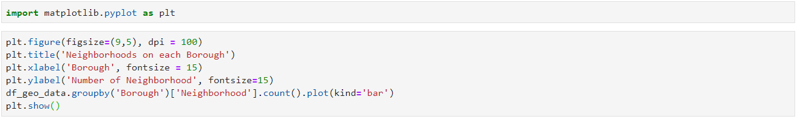

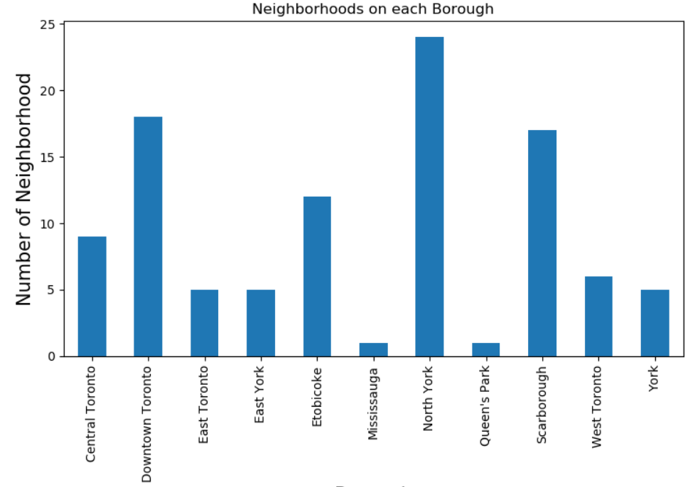

**Getting data from fourquare**

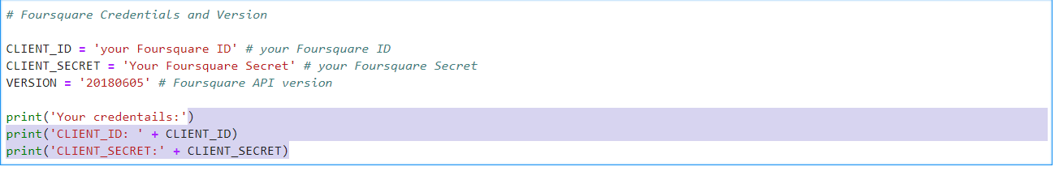

**Extracting the venues details from foursquare**

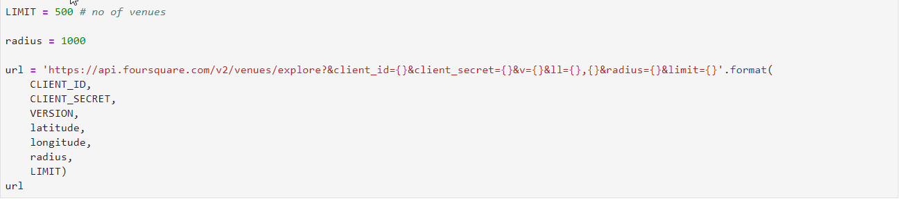

**Identifying the venue category and loading into a data frame**

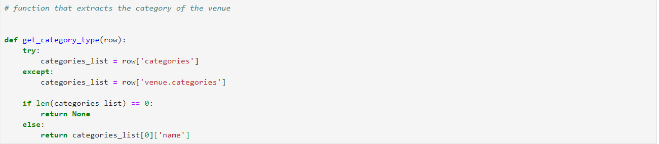

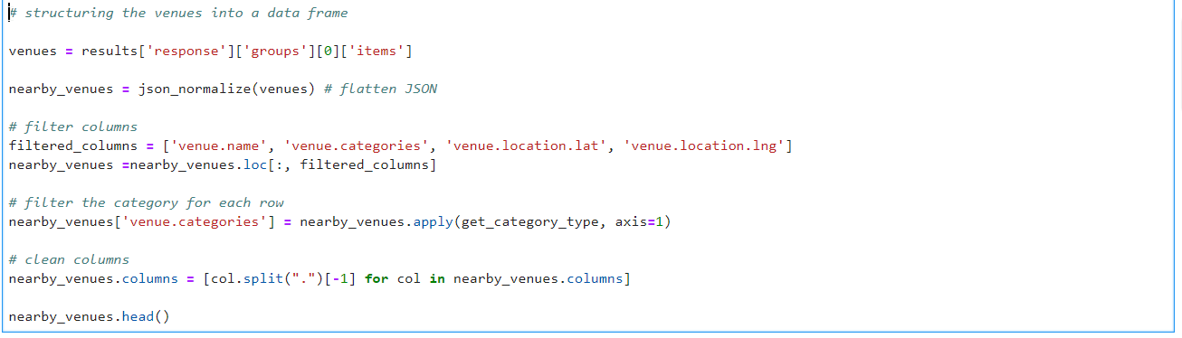

**Extracting all the venues in the Northyork Borough**

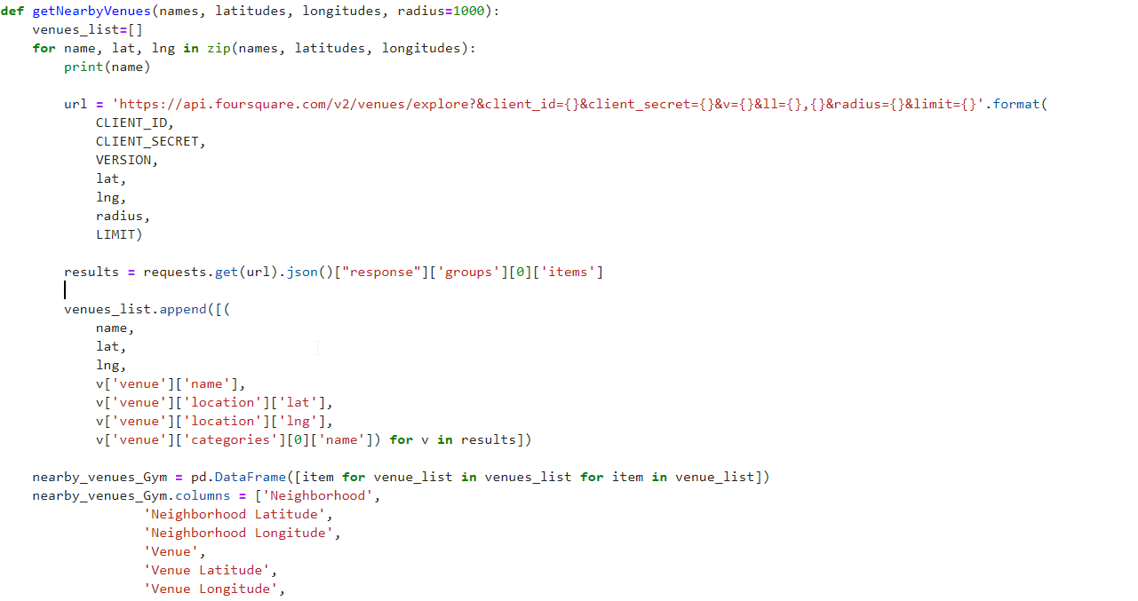

**There are 616 venues and 24 unique neighborhood in north york**

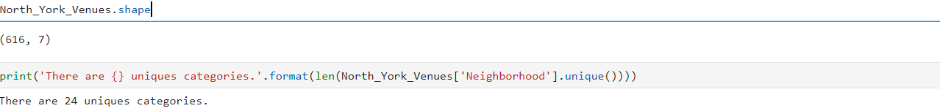

**Exploring the Recreation center and Residential buildings in north York**

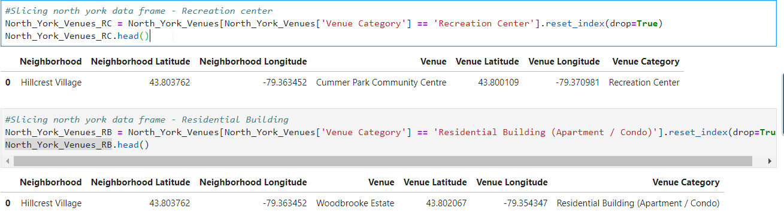

**Total number of gyms in North York in each neighborhoods,**

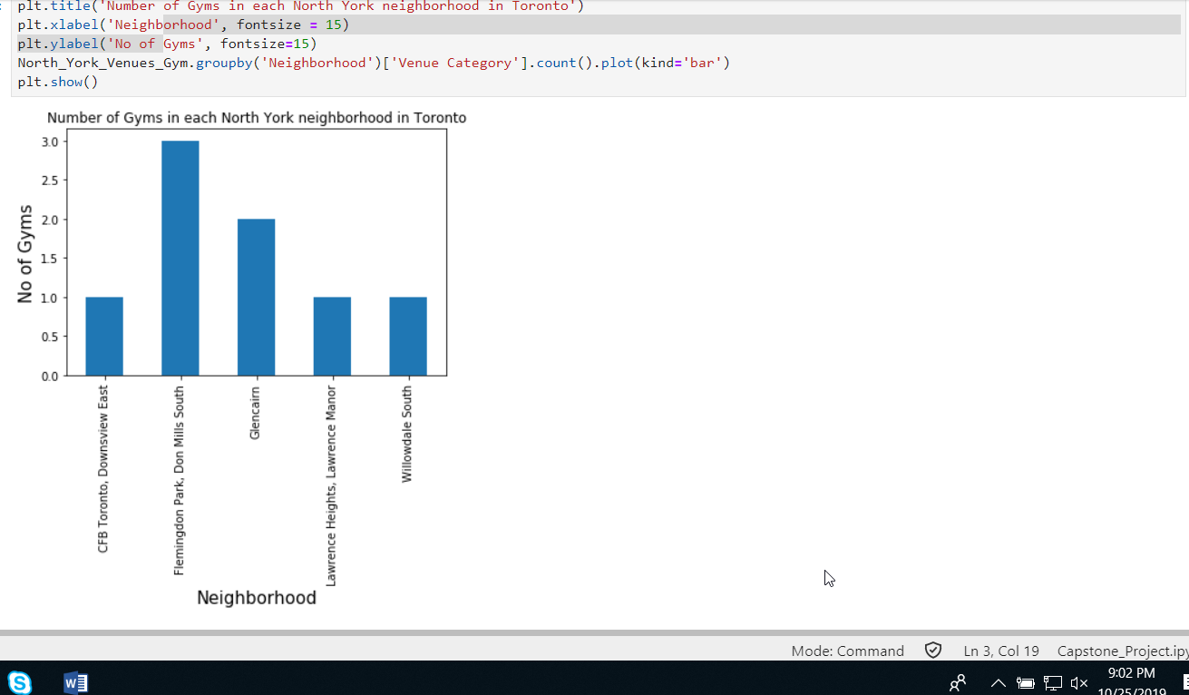

**Conclusion:**

* There are total 24 neighborhoods in North York , but only 8 gym’s are available in across 8 neighborhood.
* Hill crest village does not have a gym, 1 recreation center is available and also this neighborhood includes a residential building. Most of the residential building is equipped with physical center.
* There is large scope for physical center in North York borough.

**Assumptions, limitation and future development:**

* These results are based only the data available foursquare
* Accuracy of the data can be improved by combing other data sets related to population, and also analyzing the other categories like “indoor center”, “park”.